Code No: IT15212S
CHAITANYA BHARATHI INSTITUTE OF TECHNOLOGY (Autonomous)
BE (IT) II Yr I Sem (Suppl) Examination May/Jun 2015
DATA STRUCTURES
Time: 3 Hours Max Marks: 75
Note: Answer all questions from Section-A at one place in the same order
Answer any five questions from Section-B
Section - A (25 Marks)
1. Give a Stack ADT (2)
2. Mention the Applications of Queue (2)
3. What is meant by Binary Recursion? (2)
4. Compare time complexities of insertion sort and merge Sort (2)
5. Why do you need Hash table as a data structure as compared to any other data structure (2)
6. What is splay tree ? Give properties (3) 7. Define Tries. Explain various types of tries (3)
8. What are different types of balanced search trees? (3)
9. Write Prim's algorithm (3)
10. Give properties of B-Tree (3)
Section-B (50 Marks)
11. (a) What is the average successful search time taken by binary search on a sorted
array of 10 data items? (4)
(b) Consider an array: {25, 14, 16, 13, 10, 8, 12} represents a binary max-heap. What is
the content of the array after two delete operations on a binary max-heap? (6)

12. (a) Explain and Implement Insertion and Deletion of a node from single linked list. (6)
(b) What is recursion? Comment on the efficiency of recursive procedures (4)

13. (a) Explain any two applications of Queues (4)
(b) Give Dequeue Abstract Data Type. Implement Dequeue with a doubly linked list in C++ (6)
14. Construct a binary tree and give pre-order ,in-order ,post order for the given list 13, 3, 4, 12,
14, 10, 5, 1, 8, 2, 7, 9, 11, 6, 18 (10)

15. Give BFS and DFS for the below graph and explain algorithm (10)
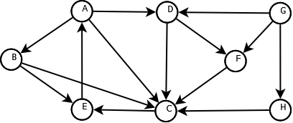

16. Define balanced search tree? Explain the following in detail
i. Properties of splay trees (3)
ii. Insertion and deletion operation in splay tree (3)
iii. Balancing of nodes after insert and delete node from AVL tree (4)
17. (a) Explain briefly about various methods to handle collision in hash tables (4)
(b) Write the steps to sort the elements by using bucket sort (choose suitable example) (6)

